Lab Experiment #2

ECE 282 - 002

Friday PM Lab

Carlos Sanchez and Connor Raasch

**Laboratory Experiment #2 Pre-Lab**

1. Draw the Logic Diagram and write the truth table for the circuit from **NAND Circuit** on p. 565 of the textbook.

| **A** | **B** | **C** | **D** | **F** |
| --- | --- | --- | --- | --- |
| 0 | 0 | 0 | 0 | 0 |
| 0 | 0 | 0 | 1 | 0 |
| 0 | 0 | 1 | 0 | 0 |
| 0 | 0 | 1 | 1 | 1 |
| 0 | 1 | 0 | 0 | 0 |
| 0 | 1 | 0 | 1 | 0 |
| 0 | 1 | 1 | 0 | 0 |
| 0 | 1 | 1 | 1 | 1 |
| 1 | 0 | 0 | 0 | 0 |
| 1 | 0 | 0 | 1 | 0 |
| 1 | 0 | 1 | 0 | 0 |
| 1 | 0 | 1 | 1 | 1 |
| 1 | 1 | 0 | 0 | 1 |
| 1 | 1 | 0 | 1 | 1 |
| 1 | 1 | 1 | 0 | 1 |
| 1 | 1 | 1 | 1 | 1 |

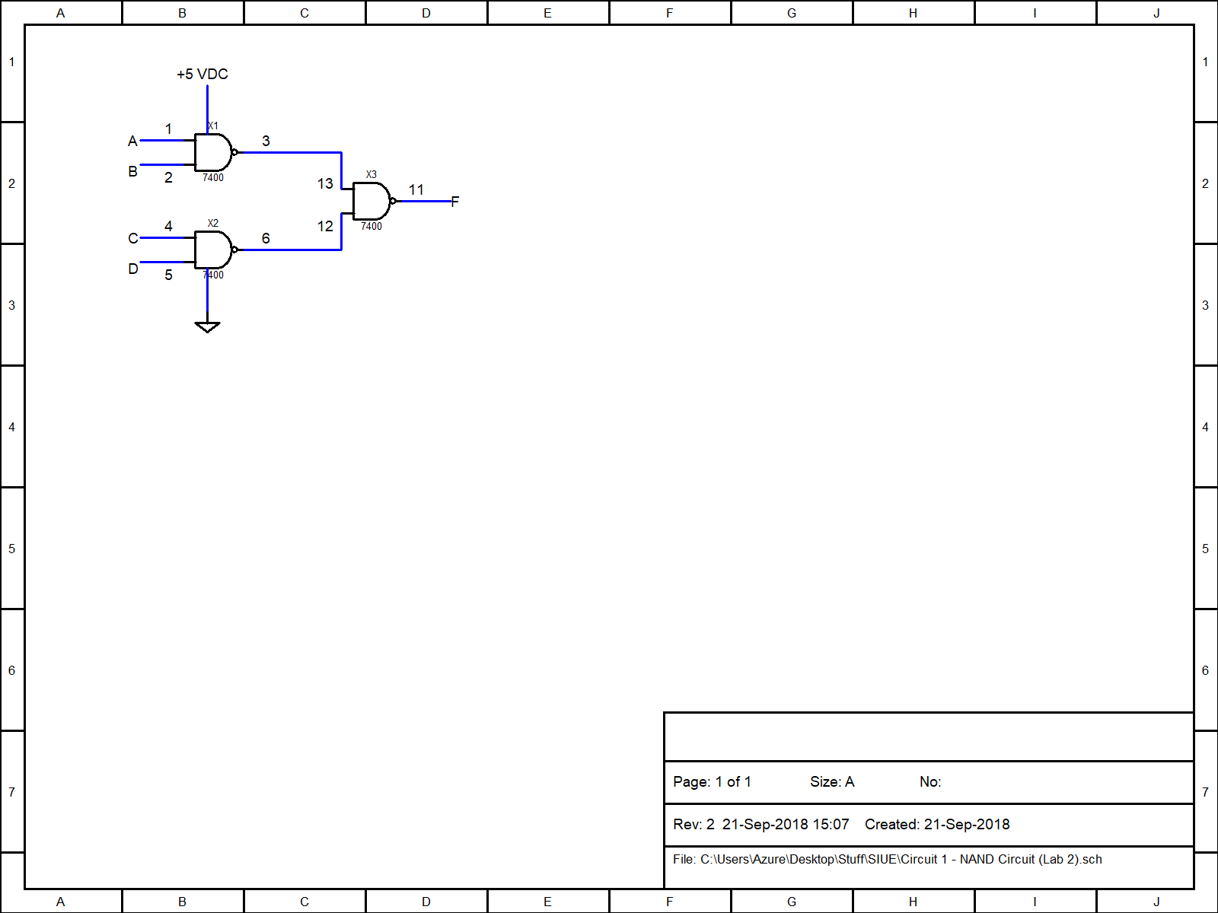

2. Draw the Logic Diagram and write the truth table for the circuit from **Logic Diagram** in Fig. 9-6 on p. 566 of the textbook and determine the simplified function in sum of products form using K-Maps.

| **X** | **Y** | **Z** | **F** |
| --- | --- | --- | --- |
| 0 | 0 | 0 | 0 |
| 0 | 0 | 1 | 0 |
| 0 | 1 | 0 | 0 |
| 0 | 1 | 1 | 1 |
| 1 | 0 | 0 | 1 |
| 1 | 0 | 1 | 1 |
| 1 | 1 | 0 | 0 |
| 1 | 1 | 1 | 1 |

3. For the two functions listed under **Boolean Functions** on p.566 of the textbook, use K-Maps to determine the simplified functions in sum of products form. Draw the Logic Diagram using a minimum number of NAND ICs.

4. For the task discussed under **Complement** on p.567 of the textbook, use K-Maps to determine the simplified functions in sum of products form and draw the Logic Diagram.

**Laboratory Experiment #2**

1. Work **NAND Circuit, parts 3, 4 and 5** from section 9.3 on p.565 and include the timing waveforms for the circuit in the lab report.

Inputs:

D0 = Clock Pulse

D1 = A

D2 = B

D3 = C

D4 = D

Outputs:

None

Inputs:

D0 = Clock Pulse

D1 = A

D2 = B

D3 = C

D4 = D

Outputs:

D5 = Output

Summary:

We used the 7400 IC to wire a circuit only using NAND gates based on the circuit diagram on our Pre-Lab Q1. We hooked up the wires to the oscilloscope, and confirmed the truth table we wrote matched the one that appeared on the oscilloscope screen. We then worked backwards and unplugged the outputs from the oscilloscope (which was step 5) and we then recorded the outputs from of the A,B,C and D as their binary counterparts.

2. Work **Logic Diagram** from section 9.4 on p.565. Demonstrate both circuits to the TA.

Inputs:

D0 = Clock Pulse

D1 = X

D2 = Y

D3 = Z

Output:

D4 = Output

Summary:

3. Work **Boolean Functions** from section 9.4 on p.566. Demonstrate the complete circuit to the TA.

4. Work **Complement** from section 9.4 on p.567. Demonstrate the complete circuit to the TA. Include the timing waveforms for the circuit in the lab report.